# Load packages
> library(bayesrules)
> library(tidyverse)
> library(rstanarm)
> library(bayesplot)
This is bayesplot version 1.10.0
- Online documentation and vignettes at mc-stan.org/bayesplot
- bayesplot theme set to bayesplot::theme_default()
* Does _not_ affect other ggplot2 plots
* See ?bayesplot_theme_set for details on theme setting
> library(tidybayes)
> library(broom.mixed)
> library(forcats)
> # Load data
> data(spotify)
>
> write.csv(spotify, "spotify.csv")
>
> spotify <- spotify %>%
+ select(artist, title, popularity) %>%
+ mutate(artist = fct_reorder(artist, popularity, .fun = 'mean'))
> # First few rows
> head(spotify, 3)
# A tibble: 3 × 3
artist title popularity
<fct> <chr> <dbl>
1 Alok On & On 79
2 Alok All The Lies 56
3 Alok Hear Me Now 75
>
> # Number of songs
> nrow(spotify)
[1] 350
> # Number of artists
> nlevels(spotify$artist)
[1] 44
> artist_means <- spotify %>%
+ group_by(artist) %>%
+ summarize(count = n(), popularity = mean(popularity))
> artist_means %>%
+ slice(1:2, 43:44)
# A tibble: 4 × 3
artist count popularity
<fct> <int> <dbl>
1 Mia X 4 13.2
2 Chris Goldarg 10 16.4
3 Lil Skies 3 79.3
4 Camilo 9 81
> head(artist_means, 2)
# A tibble: 2 × 3
artist count popularity
<fct> <int> <dbl>
1 Mia X 4 13.2
2 Chris Goldarg 10 16.4
>
> artist_means %>%
+ summarize(min(count), max(count))
# A tibble: 1 × 2
`min(count)` `max(count)`
<int> <int>
1 2 40
>
> ggplot(spotify, aes(x = popularity)) +
+ geom_density()
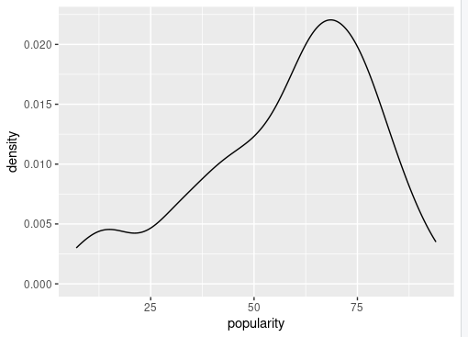

spotify_complete_pooled <- stan_glm(
+ popularity ~ 1,
+ data = spotify, family = gaussian,
+ prior_intercept = normal(50, 2.5, autoscale = TRUE),
+ prior_aux = exponential(1, autoscale = TRUE),
+ chains = 4, iter = 5000*2, seed = 84735)

SAMPLING FOR MODEL 'continuous' NOW (CHAIN 1).
Chain 1:
Chain 1: Gradient evaluation took 2.6e-05 seconds
Chain 1: 1000 transitions using 10 leapfrog steps per transition would take 0.26 seconds.
Chain 1: Adjust your expectations accordingly!
Chain 1:
Chain 1:
Chain 1: Iteration: 1 / 10000 [ 0%] (Warmup)
Chain 1: Iteration: 1000 / 10000 [ 10%] (Warmup)
Chain 1: Iteration: 2000 / 10000 [ 20%] (Warmup)
Chain 1: Iteration: 3000 / 10000 [ 30%] (Warmup)
Chain 1: Iteration: 4000 / 10000 [ 40%] (Warmup)
Chain 1: Iteration: 5000 / 10000 [ 50%] (Warmup)
Chain 1: Iteration: 5001 / 10000 [ 50%] (Sampling)
Chain 1: Iteration: 6000 / 10000 [ 60%] (Sampling)
Chain 1: Iteration: 7000 / 10000 [ 70%] (Sampling)
Chain 1: Iteration: 8000 / 10000 [ 80%] (Sampling)
Chain 1: Iteration: 9000 / 10000 [ 90%] (Sampling)
Chain 1: Iteration: 10000 / 10000 [100%] (Sampling)
Chain 1:
Chain 1: Elapsed Time: 0.18168 seconds (Warm-up)
Chain 1: 0.485814 seconds (Sampling)
Chain 1: 0.667494 seconds (Total)
Chain 1:

SAMPLING FOR MODEL 'continuous' NOW (CHAIN 2).
Chain 2:
Chain 2: Gradient evaluation took 2.8e-05 seconds
Chain 2: 1000 transitions using 10 leapfrog steps per transition would take 0.28 seconds.
Chain 2: Adjust your expectations accordingly!
Chain 2:
Chain 2:
Chain 2: Iteration: 1 / 10000 [ 0%] (Warmup)
Chain 2: Iteration: 1000 / 10000 [ 10%] (Warmup)
Chain 2: Iteration: 2000 / 10000 [ 20%] (Warmup)
Chain 2: Iteration: 3000 / 10000 [ 30%] (Warmup)
Chain 2: Iteration: 4000 / 10000 [ 40%] (Warmup)
Chain 2: Iteration: 5000 / 10000 [ 50%] (Warmup)
Chain 2: Iteration: 5001 / 10000 [ 50%] (Sampling)
Chain 2: Iteration: 6000 / 10000 [ 60%] (Sampling)
Chain 2: Iteration: 7000 / 10000 [ 70%] (Sampling)
Chain 2: Iteration: 8000 / 10000 [ 80%] (Sampling)
Chain 2: Iteration: 9000 / 10000 [ 90%] (Sampling)
Chain 2: Iteration: 10000 / 10000 [100%] (Sampling)
Chain 2:
Chain 2: Elapsed Time: 0.300341 seconds (Warm-up)
Chain 2: 0.605696 seconds (Sampling)
Chain 2: 0.906037 seconds (Total)
Chain 2:

SAMPLING FOR MODEL 'continuous' NOW (CHAIN 3).
Chain 3:
Chain 3: Gradient evaluation took 2.8e-05 seconds
Chain 3: 1000 transitions using 10 leapfrog steps per transition would take 0.28 seconds.
Chain 3: Adjust your expectations accordingly!
Chain 3:
Chain 3:
Chain 3: Iteration: 1 / 10000 [ 0%] (Warmup)
Chain 3: Iteration: 1000 / 10000 [ 10%] (Warmup)
Chain 3: Iteration: 2000 / 10000 [ 20%] (Warmup)
Chain 3: Iteration: 3000 / 10000 [ 30%] (Warmup)
Chain 3: Iteration: 4000 / 10000 [ 40%] (Warmup)
Chain 3: Iteration: 5000 / 10000 [ 50%] (Warmup)
Chain 3: Iteration: 5001 / 10000 [ 50%] (Sampling)
Chain 3: Iteration: 6000 / 10000 [ 60%] (Sampling)
Chain 3: Iteration: 7000 / 10000 [ 70%] (Sampling)
Chain 3: Iteration: 8000 / 10000 [ 80%] (Sampling)
Chain 3: Iteration: 9000 / 10000 [ 90%] (Sampling)
Chain 3: Iteration: 10000 / 10000 [100%] (Sampling)
Chain 3:
Chain 3: Elapsed Time: 0.24199 seconds (Warm-up)
Chain 3: 0.482474 seconds (Sampling)
Chain 3: 0.724464 seconds (Total)
Chain 3:

SAMPLING FOR MODEL 'continuous' NOW (CHAIN 4).
Chain 4:
Chain 4: Gradient evaluation took 3e-05 seconds
Chain 4: 1000 transitions using 10 leapfrog steps per transition would take 0.3 seconds.
Chain 4: Adjust your expectations accordingly!
Chain 4:
Chain 4:
Chain 4: Iteration: 1 / 10000 [ 0%] (Warmup)
Chain 4: Iteration: 1000 / 10000 [ 10%] (Warmup)
Chain 4: Iteration: 2000 / 10000 [ 20%] (Warmup)
Chain 4: Iteration: 3000 / 10000 [ 30%] (Warmup)
Chain 4: Iteration: 4000 / 10000 [ 40%] (Warmup)
Chain 4: Iteration: 5000 / 10000 [ 50%] (Warmup)
Chain 4: Iteration: 5001 / 10000 [ 50%] (Sampling)
Chain 4: Iteration: 6000 / 10000 [ 60%] (Sampling)
Chain 4: Iteration: 7000 / 10000 [ 70%] (Sampling)
Chain 4: Iteration: 8000 / 10000 [ 80%] (Sampling)
Chain 4: Iteration: 9000 / 10000 [ 90%] (Sampling)
Chain 4: Iteration: 10000 / 10000 [100%] (Sampling)
Chain 4:
Chain 4: Elapsed Time: 0.247257 seconds (Warm-up)
Chain 4: 0.406095 seconds (Sampling)
Chain 4: 0.653352 seconds (Total)
Chain 4:
# Get prior specifications
> prior_summary(spotify_complete_pooled)
Priors for model 'spotify_complete_pooled'
------
Intercept (after predictors centered)
Specified prior:
~ normal(location = 50, scale = 2.5)
Adjusted prior:
~ normal(location = 50, scale = 52)

Auxiliary (sigma)
Specified prior:
~ exponential(rate = 1)
Adjusted prior:
~ exponential(rate = 0.048)
------
See help('prior_summary.stanreg') for more details
> complete_summary <- tidy(spotify_complete_pooled,
+ effects = c("fixed", "aux"),
+ conf.int = TRUE, conf.level = 0.80)
> complete_summary
# A tibble: 3 × 5
term estimate std.error conf.low conf.high
<chr> <dbl> <dbl> <dbl> <dbl>
1 (Intercept) 58.4 1.10 57.0 59.8
2 sigma 20.7 0.776 19.7 21.7
3 mean_PPD 58.4 1.57 56.4 60.4
> set.seed(84735)
> predictions_complete <- posterior_predict(spotify_complete_pooled,
+ newdata = artist_means)
> ppc_intervals(artist_means$popularity, yrep = predictions_complete,
+ prob_outer = 0.80) +
+ ggplot2::scale_x_continuous(labels = artist_means$artist,
+ breaks = 1:nrow(artist_means)) +
+ xaxis_text(angle = 90, hjust = 1)

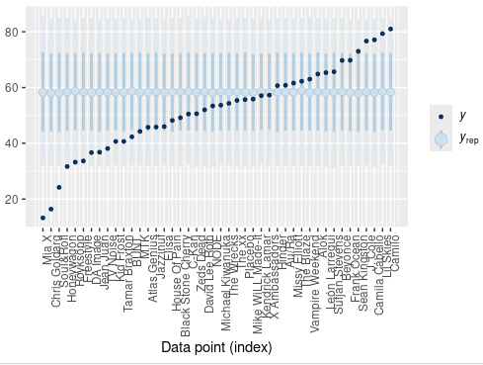

> ggplot(spotify, aes(x = popularity, group = artist)) +
+ geom_density()

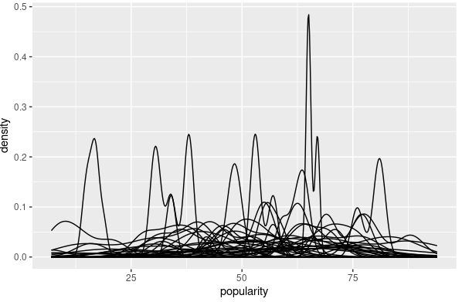

spotify_no_pooled <- stan_glm(
+ popularity ~ artist - 1,
+ data = spotify, family = gaussian,
+ prior = normal(50, 2.5, autoscale = TRUE),
+ prior_aux = exponential(1, autoscale = TRUE),
+ chains = 4, iter = 5000*2, seed = 84735)

SAMPLING FOR MODEL 'continuous' NOW (CHAIN 1).
Chain 1:
Chain 1: Gradient evaluation took 7.9e-05 seconds
Chain 1: 1000 transitions using 10 leapfrog steps per transition would take 0.79 seconds.
Chain 1: Adjust your expectations accordingly!
Chain 1:
Chain 1:
Chain 1: Iteration: 1 / 10000 [ 0%] (Warmup)
Chain 1: Iteration: 1000 / 10000 [ 10%] (Warmup)
Chain 1: Iteration: 2000 / 10000 [ 20%] (Warmup)
Chain 1: Iteration: 3000 / 10000 [ 30%] (Warmup)
Chain 1: Iteration: 4000 / 10000 [ 40%] (Warmup)
Chain 1: Iteration: 5000 / 10000 [ 50%] (Warmup)
Chain 1: Iteration: 5001 / 10000 [ 50%] (Sampling)
Chain 1: Iteration: 6000 / 10000 [ 60%] (Sampling)
Chain 1: Iteration: 7000 / 10000 [ 70%] (Sampling)
Chain 1: Iteration: 8000 / 10000 [ 80%] (Sampling)
Chain 1: Iteration: 9000 / 10000 [ 90%] (Sampling)
Chain 1: Iteration: 10000 / 10000 [100%] (Sampling)
Chain 1:
Chain 1: Elapsed Time: 1.14653 seconds (Warm-up)
Chain 1: 1.4368 seconds (Sampling)
Chain 1: 2.58333 seconds (Total)
Chain 1:

SAMPLING FOR MODEL 'continuous' NOW (CHAIN 2).
Chain 2:
Chain 2: Gradient evaluation took 4.6e-05 seconds
Chain 2: 1000 transitions using 10 leapfrog steps per transition would take 0.46 seconds.
Chain 2: Adjust your expectations accordingly!
Chain 2:
Chain 2:
Chain 2: Iteration: 1 / 10000 [ 0%] (Warmup)
Chain 2: Iteration: 1000 / 10000 [ 10%] (Warmup)
Chain 2: Iteration: 2000 / 10000 [ 20%] (Warmup)
Chain 2: Iteration: 3000 / 10000 [ 30%] (Warmup)
Chain 2: Iteration: 4000 / 10000 [ 40%] (Warmup)
Chain 2: Iteration: 5000 / 10000 [ 50%] (Warmup)
Chain 2: Iteration: 5001 / 10000 [ 50%] (Sampling)
Chain 2: Iteration: 6000 / 10000 [ 60%] (Sampling)
Chain 2: Iteration: 7000 / 10000 [ 70%] (Sampling)
Chain 2: Iteration: 8000 / 10000 [ 80%] (Sampling)
Chain 2: Iteration: 9000 / 10000 [ 90%] (Sampling)
Chain 2: Iteration: 10000 / 10000 [100%] (Sampling)
Chain 2:
Chain 2: Elapsed Time: 1.18771 seconds (Warm-up)
Chain 2: 1.3573 seconds (Sampling)
Chain 2: 2.54501 seconds (Total)
Chain 2:

SAMPLING FOR MODEL 'continuous' NOW (CHAIN 3).
Chain 3:
Chain 3: Gradient evaluation took 5.5e-05 seconds
Chain 3: 1000 transitions using 10 leapfrog steps per transition would take 0.55 seconds.
Chain 3: Adjust your expectations accordingly!
Chain 3:
Chain 3:
Chain 3: Iteration: 1 / 10000 [ 0%] (Warmup)
Chain 3: Iteration: 1000 / 10000 [ 10%] (Warmup)
Chain 3: Iteration: 2000 / 10000 [ 20%] (Warmup)
Chain 3: Iteration: 3000 / 10000 [ 30%] (Warmup)
Chain 3: Iteration: 4000 / 10000 [ 40%] (Warmup)
Chain 3: Iteration: 5000 / 10000 [ 50%] (Warmup)
Chain 3: Iteration: 5001 / 10000 [ 50%] (Sampling)
Chain 3: Iteration: 6000 / 10000 [ 60%] (Sampling)
Chain 3: Iteration: 7000 / 10000 [ 70%] (Sampling)
Chain 3: Iteration: 8000 / 10000 [ 80%] (Sampling)
Chain 3: Iteration: 9000 / 10000 [ 90%] (Sampling)
Chain 3: Iteration: 10000 / 10000 [100%] (Sampling)
Chain 3:
Chain 3: Elapsed Time: 1.11494 seconds (Warm-up)
Chain 3: 1.39524 seconds (Sampling)
Chain 3: 2.51018 seconds (Total)
Chain 3:

SAMPLING FOR MODEL 'continuous' NOW (CHAIN 4).
Chain 4:
Chain 4: Gradient evaluation took 3.6e-05 seconds
Chain 4: 1000 transitions using 10 leapfrog steps per transition would take 0.36 seconds.
Chain 4: Adjust your expectations accordingly!
Chain 4:
Chain 4:
Chain 4: Iteration: 1 / 10000 [ 0%] (Warmup)
Chain 4: Iteration: 1000 / 10000 [ 10%] (Warmup)
Chain 4: Iteration: 2000 / 10000 [ 20%] (Warmup)
Chain 4: Iteration: 3000 / 10000 [ 30%] (Warmup)
Chain 4: Iteration: 4000 / 10000 [ 40%] (Warmup)
Chain 4: Iteration: 5000 / 10000 [ 50%] (Warmup)
Chain 4: Iteration: 5001 / 10000 [ 50%] (Sampling)
Chain 4: Iteration: 6000 / 10000 [ 60%] (Sampling)
Chain 4: Iteration: 7000 / 10000 [ 70%] (Sampling)
Chain 4: Iteration: 8000 / 10000 [ 80%] (Sampling)
Chain 4: Iteration: 9000 / 10000 [ 90%] (Sampling)
Chain 4: Iteration: 10000 / 10000 [100%] (Sampling)
Chain 4:
Chain 4: Elapsed Time: 1.28672 seconds (Warm-up)
Chain 4: 1.72111 seconds (Sampling)
Chain 4: 3.00783 seconds (Total)
Chain 4:

# Simulate the posterior predictive models
> set.seed(84735)
> predictions_no <- posterior_predict(
+ spotify_no_pooled, newdata = artist_means)
> # Plot the posterior predictive intervals
> ppc_intervals(artist_means$popularity, yrep = predictions_no,
+ prob_outer = 0.80) +
+ ggplot2::scale_x_continuous(labels = artist_means$artist,
+ breaks = 1:nrow(artist_means)) +
+ xaxis_text(angle = 90, hjust = 1)

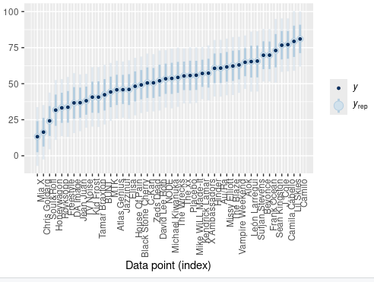

> ggplot(artist_means, aes(x = popularity)) +
+ geom_density()

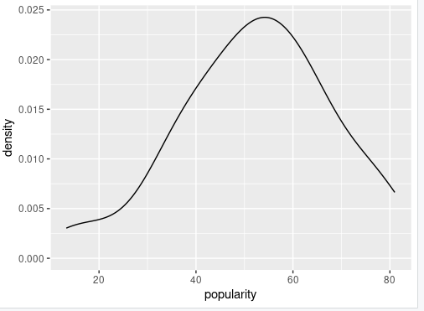

spotify_hierarchical <- stan_glmer(
+ popularity ~ (1 | artist),
+ data = spotify, family = gaussian,
+ prior_intercept = normal(50, 2.5, autoscale = TRUE),
+ prior_aux = exponential(1, autoscale = TRUE),
+ prior_covariance = decov(reg = 1, conc = 1, shape = 1, scale = 1),
+ chains = 4, iter = 5000*2, seed = 84735)

SAMPLING FOR MODEL 'continuous' NOW (CHAIN 1).
Chain 1:
Chain 1: Gradient evaluation took 0.000106 seconds
Chain 1: 1000 transitions using 10 leapfrog steps per transition would take 1.06 seconds.
Chain 1: Adjust your expectations accordingly!
Chain 1:
Chain 1:
Chain 1: Iteration: 1 / 10000 [ 0%] (Warmup)
Chain 1: Iteration: 1000 / 10000 [ 10%] (Warmup)
Chain 1: Iteration: 2000 / 10000 [ 20%] (Warmup)
Chain 1: Iteration: 3000 / 10000 [ 30%] (Warmup)
Chain 1: Iteration: 4000 / 10000 [ 40%] (Warmup)
Chain 1: Iteration: 5000 / 10000 [ 50%] (Warmup)
Chain 1: Iteration: 5001 / 10000 [ 50%] (Sampling)
Chain 1: Iteration: 6000 / 10000 [ 60%] (Sampling)
Chain 1: Iteration: 7000 / 10000 [ 70%] (Sampling)
Chain 1: Iteration: 8000 / 10000 [ 80%] (Sampling)
Chain 1: Iteration: 9000 / 10000 [ 90%] (Sampling)
Chain 1: Iteration: 10000 / 10000 [100%] (Sampling)
Chain 1:
Chain 1: Elapsed Time: 3.80463 seconds (Warm-up)
Chain 1: 2.95481 seconds (Sampling)
Chain 1: 6.75944 seconds (Total)
Chain 1:

SAMPLING FOR MODEL 'continuous' NOW (CHAIN 2).
Chain 2:
Chain 2: Gradient evaluation took 4.9e-05 seconds
Chain 2: 1000 transitions using 10 leapfrog steps per transition would take 0.49 seconds.
Chain 2: Adjust your expectations accordingly!
Chain 2:
Chain 2:
Chain 2: Iteration: 1 / 10000 [ 0%] (Warmup)
Chain 2: Iteration: 1000 / 10000 [ 10%] (Warmup)
Chain 2: Iteration: 2000 / 10000 [ 20%] (Warmup)
Chain 2: Iteration: 3000 / 10000 [ 30%] (Warmup)
Chain 2: Iteration: 4000 / 10000 [ 40%] (Warmup)
Chain 2: Iteration: 5000 / 10000 [ 50%] (Warmup)
Chain 2: Iteration: 5001 / 10000 [ 50%] (Sampling)
Chain 2: Iteration: 6000 / 10000 [ 60%] (Sampling)
Chain 2: Iteration: 7000 / 10000 [ 70%] (Sampling)
Chain 2: Iteration: 8000 / 10000 [ 80%] (Sampling)
Chain 2: Iteration: 9000 / 10000 [ 90%] (Sampling)
Chain 2: Iteration: 10000 / 10000 [100%] (Sampling)
Chain 2:
Chain 2: Elapsed Time: 4.23747 seconds (Warm-up)
Chain 2: 4.5965 seconds (Sampling)
Chain 2: 8.83397 seconds (Total)
Chain 2:

SAMPLING FOR MODEL 'continuous' NOW (CHAIN 3).
Chain 3:
Chain 3: Gradient evaluation took 4.7e-05 seconds
Chain 3: 1000 transitions using 10 leapfrog steps per transition would take 0.47 seconds.
Chain 3: Adjust your expectations accordingly!
Chain 3:
Chain 3:
Chain 3: Iteration: 1 / 10000 [ 0%] (Warmup)
Chain 3: Iteration: 1000 / 10000 [ 10%] (Warmup)
Chain 3: Iteration: 2000 / 10000 [ 20%] (Warmup)
Chain 3: Iteration: 3000 / 10000 [ 30%] (Warmup)
Chain 3: Iteration: 4000 / 10000 [ 40%] (Warmup)
Chain 3: Iteration: 5000 / 10000 [ 50%] (Warmup)
Chain 3: Iteration: 5001 / 10000 [ 50%] (Sampling)
Chain 3: Iteration: 6000 / 10000 [ 60%] (Sampling)
Chain 3: Iteration: 7000 / 10000 [ 70%] (Sampling)
Chain 3: Iteration: 8000 / 10000 [ 80%] (Sampling)
Chain 3: Iteration: 9000 / 10000 [ 90%] (Sampling)
Chain 3: Iteration: 10000 / 10000 [100%] (Sampling)
Chain 3:
Chain 3: Elapsed Time: 3.56585 seconds (Warm-up)
Chain 3: 4.44999 seconds (Sampling)
Chain 3: 8.01584 seconds (Total)
Chain 3:

SAMPLING FOR MODEL 'continuous' NOW (CHAIN 4).
Chain 4:
Chain 4: Gradient evaluation took 4.6e-05 seconds
Chain 4: 1000 transitions using 10 leapfrog steps per transition would take 0.46 seconds.
Chain 4: Adjust your expectations accordingly!
Chain 4:
Chain 4:
Chain 4: Iteration: 1 / 10000 [ 0%] (Warmup)
Chain 4: Iteration: 1000 / 10000 [ 10%] (Warmup)
Chain 4: Iteration: 2000 / 10000 [ 20%] (Warmup)
Chain 4: Iteration: 3000 / 10000 [ 30%] (Warmup)
Chain 4: Iteration: 4000 / 10000 [ 40%] (Warmup)
Chain 4: Iteration: 5000 / 10000 [ 50%] (Warmup)
Chain 4: Iteration: 5001 / 10000 [ 50%] (Sampling)
Chain 4: Iteration: 6000 / 10000 [ 60%] (Sampling)
Chain 4: Iteration: 7000 / 10000 [ 70%] (Sampling)
Chain 4: Iteration: 8000 / 10000 [ 80%] (Sampling)
Chain 4: Iteration: 9000 / 10000 [ 90%] (Sampling)
Chain 4: Iteration: 10000 / 10000 [100%] (Sampling)
Chain 4:
Chain 4: Elapsed Time: 3.63024 seconds (Warm-up)
Chain 4: 4.05515 seconds (Sampling)
Chain 4: 7.68538 seconds (Total)
Chain 4:
> # Confirm the prior tunings
> prior_summary(spotify_hierarchical)
Priors for model 'spotify_hierarchical'
------
Intercept (after predictors centered)
Specified prior:
~ normal(location = 50, scale = 2.5)
Adjusted prior:
~ normal(location = 50, scale = 52)

Auxiliary (sigma)
Specified prior:
~ exponential(rate = 1)
Adjusted prior:
~ exponential(rate = 0.048)

Covariance
~ decov(reg. = 1, conc. = 1, shape = 1, scale = 1)
------
See help('prior_summary.stanreg') for more details

mcmc_trace(spotify_hierarchical)
> mcmc_dens_overlay(spotify_hierarchical)
> mcmc_acf(spotify_hierarchical)
Error:
! The `facets` argument of `facet_grid()` was deprecated in ggplot2 2.2.0 and is now
defunct.
ℹ Please use the `rows` argument instead.

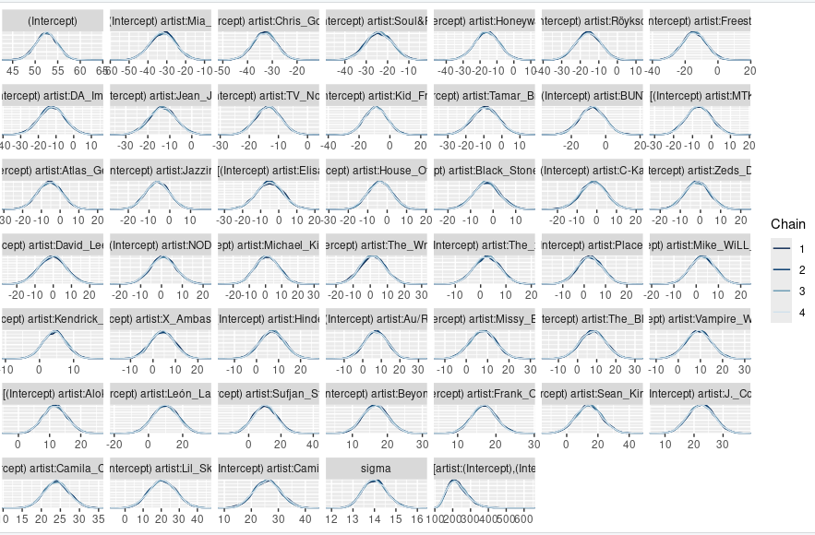

> pp_check(spotify_hierarchical) +
+ xlab("popularity")

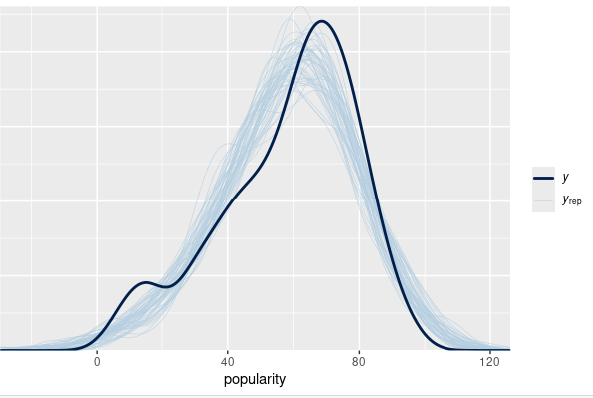

# Store the simulation in a data frame
> spotify_hierarchical_df <- as.data.frame(spotify_hierarchical)
> # Check out the first 3 and last 3 parameter labels
> spotify_hierarchical_df %>%
+ colnames() %>%
+ as.data.frame() %>%
+ slice(1:3, 45:47)
.
1 (Intercept)
2 b[(Intercept) artist:Mia_X]
3 b[(Intercept) artist:Chris_Goldarg]
4 b[(Intercept) artist:Camilo]
5 sigma
6 Sigma[artist:(Intercept),(Intercept)]
> tidy(spotify_hierarchical, effects = "fixed",
+ conf.int = TRUE, conf.level = 0.80)
# A tibble: 1 × 5
term estimate std.error conf.low conf.high
<chr> <dbl> <dbl> <dbl> <dbl>
1 (Intercept) 52.5 2.41 49.4 55.6
> tidy(spotify_hierarchical, effects = "ran_pars")
# A tibble: 2 × 3
term group estimate
<chr> <chr> <dbl>
1 sd_(Intercept).artist artist 15.2
2 sd_Observation.Residual Residual 14.0
>
> 15.1^2 / (15.1^2 + 14.0^2)
[1] 0.5377468
>
> 14.0^2 / (15.1^2 + 14.0^2)
[1] 0.4622532
> artist_summary <- tidy(spotify_hierarchical, effects = "ran_vals",
+ conf.int = TRUE, conf.level = 0.80)
> # Check out the results for the first & last 2 artists
> artist_summary %>%
+ select(level, conf.low, conf.high) %>%
+ slice(1:2, 43:44)
# A tibble: 4 × 3
level conf.low conf.high
<chr> <dbl> <dbl>
1 Mia_X -40.8 -23.4
2 Chris_Goldarg -39.3 -27.0
3 Lil_Skies 11.2 30.4
4 Camilo 19.5 32.4
> # Get MCMC chains for each mu_j
> artist_chains <- spotify_hierarchical %>%
+ spread_draws(`(Intercept)`, b[,artist]) %>%
+ mutate(mu_j = `(Intercept)` + b)
> # Check it out
> artist_chains %>%
+ select(artist, `(Intercept)`, b, mu_j) %>%
+ head(4)
# A tibble: 4 × 4
# Groups: artist [4]
artist `(Intercept)` b mu_j
<chr> <dbl> <dbl> <dbl>
1 artist:Alok 55.0 1.90 56.9
2 artist:Atlas_Genius 55.0 -13.9 41.1
3 artist:Au/Ra 55.0 7.40 62.4
4 artist:Beyoncé 55.0 12.7 67.7

# Get posterior summaries for mu_j
> artist_summary_scaled <- artist_chains %>%
+ select(-`(Intercept)`, -b) %>%
+ mean_qi(.width = 0.80) %>%
+ mutate(artist = fct_reorder(artist, mu_j))
> # Check out the results
> artist_summary_scaled %>%
+ select(artist, mu_j, .lower, .upper) %>%
+ head(4)
# A tibble: 4 × 4
artist mu_j .lower .upper
<fct> <dbl> <dbl> <dbl>
1 artist:Alok 64.3 60.3 68.2
2 artist:Atlas_Genius 47.0 39.0 55.1
3 artist:Au/Ra 59.5 52.1 67.0
4 artist:Beyoncé 69.1 65.6 72.6
> ggplot(artist_summary_scaled,
+ aes(x = artist, y = mu_j, ymin = .lower, ymax = .upper)) +
+ geom_pointrange() +
+ xaxis_text(angle = 90, hjust = 1)

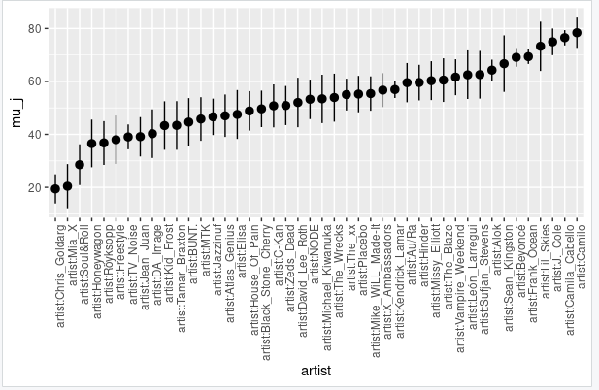

artist_means %>%
+ filter(artist %in% c("Frank Ocean", "Lil Skies"))
# A tibble: 2 × 3
artist count popularity
<fct> <int> <dbl>
1 Frank Ocean 40 69.8
2 Lil Skies 3 79.3
> # Simulate Ocean's posterior predictive model
> set.seed(84735)
> ocean_chains <- spotify_hierarchical_df %>%
+ rename(b = `b[(Intercept) artist:Frank_Ocean]`) %>%
+ select(`(Intercept)`, b, sigma) %>%
+ mutate(mu_ocean = `(Intercept)` + b,
+ y_ocean = rnorm(20000, mean = mu_ocean, sd = sigma))
> # Check it out
> head(ocean_chains, 3)
(Intercept) b sigma mu_ocean y_ocean
1 54.95515 13.90461 13.86577 68.85977 78.11146
2 54.80783 14.60211 14.16950 69.40994 67.65519
3 53.95050 16.08448 13.91206 70.03498 80.89846
> # Posterior summary of Y_new,j
> ocean_chains %>%
+ mean_qi(y_ocean, .width = 0.80)
# A tibble: 1 × 6
y_ocean .lower .upper .width .point .interval
<dbl> <dbl> <dbl> <dbl> <chr> <chr>
1 69.4 51.3 87.5 0.8 mean qi
> # A tibble: 1 x 6
>
> # Posterior summary of mu_j
> artist_summary_scaled %>%
+ filter(artist == "artist:Frank_Ocean")
# A tibble: 1 × 7
artist mu_j .lower .upper .width .point .interval
<fct> <dbl> <dbl> <dbl> <dbl> <chr> <chr>
1 artist:Frank_Ocean 69.4 66.6 72.1 0.8 mean qi
> set.seed(84735)
> mohsen_chains <- spotify_hierarchical_df %>%
+ mutate(sigma_mu = sqrt(`Sigma[artist:(Intercept),(Intercept)]`),
+ mu_mohsen = rnorm(20000, `(Intercept)`, sigma_mu),
+ y_mohsen = rnorm(20000, mu_mohsen, sigma))
> # Posterior predictive summaries
> mohsen_chains %>%
+ mean_qi(y_mohsen, .width = 0.80)
# A tibble: 1 × 6
y_mohsen .lower .upper .width .point .interval
<dbl> <dbl> <dbl> <dbl> <chr> <chr>
1 52.3 25.9 78.6 0.8 mean qi
> set.seed(84735)
> prediction_shortcut <- posterior_predict(
+ spotify_hierarchical,
+ newdata = data.frame(artist = c("Frank Ocean", "Mohsen Beats")))
> # Posterior predictive model plots
> mcmc_areas(prediction_shortcut, prob = 0.8) +
+ ggplot2::scale_y_discrete(labels = c("Frank Ocean", "Mohsen Beats"))
Scale for y is already present.
Adding another scale for y, which will replace the existing scale.

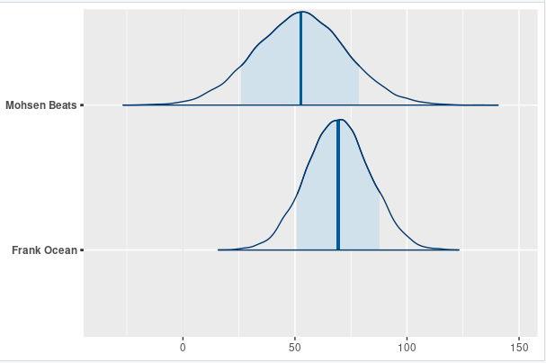

set.seed(84735)
> predictions_hierarchical <- posterior_predict(spotify_hierarchical,
+ newdata = artist_means)
> # Posterior predictive plots
> ppc_intervals(artist_means$popularity, yrep = predictions_hierarchical,
+ prob_outer = 0.80) +
+ ggplot2::scale_x_continuous(labels = artist_means$artist,
+ breaks = 1:nrow(artist_means)) +
+ xaxis_text(angle = 90, hjust = 1) +
+ geom_hline(yintercept = 58.4, linetype = "dashed")

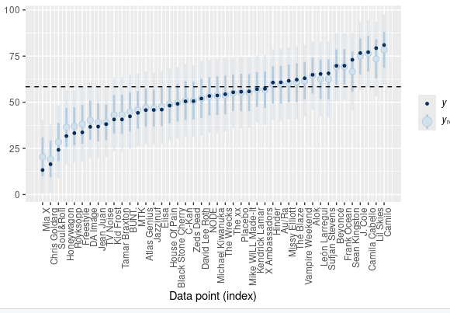

data(bikes)
> bikes %>%
+ select(rides, weekend) %>%
+ head(3)
rides weekend
1 654 TRUE
2 1229 FALSE
3 1454 FALSE
>
> bikes %>%
+ group_by(weekend) %>%
+ tally()
# A tibble: 2 × 2
weekend n
<lgl> <int>
1 FALSE 359
2 TRUE 141
>
> data(big_word_club)
> big_word_club <- big_word_club %>%
+ select(score_a2, school_id) %>%
+ na.omit()
> big_word_club %>%
+ slice(1:2, 602:603)
score_a2 school_id
1 28 1
2 25 1
3 31 47
4 34 47
> data("big_word_club")
> big_word_club <- big_word_club %>%
+ filter(treat == 1) %>%
+ select(school_id, score_pct_change) %>%
+ na.omit()

